Chain & Plexiglas

? x ?

Received: 3.4

Time Spent: 13 hours

Initial Reaction: 4/10

Cost of Materials: $80

This work was received badly in crit and received an overall grade of 3.4 upon evaluation. The total hours/money spent on labor and cost of materials was above average.

Add To Cart: **$28.60** [See Pricing Sheet](Pricing%20Sheet.docx)





Paper & Ink

11”x 8.5”

Received: 3.4

Time Spent: 4 hours

Initial Reaction: 8/10

Cost of Materials: $24

This work was received very well in crit and received an overall grade of 3.4 upon evaluation. The total hours/money spent on labor and cost of materials was below average.

Add To Cart: **$412** [See Pricing Sheet](Pricing%20Sheet.docx)

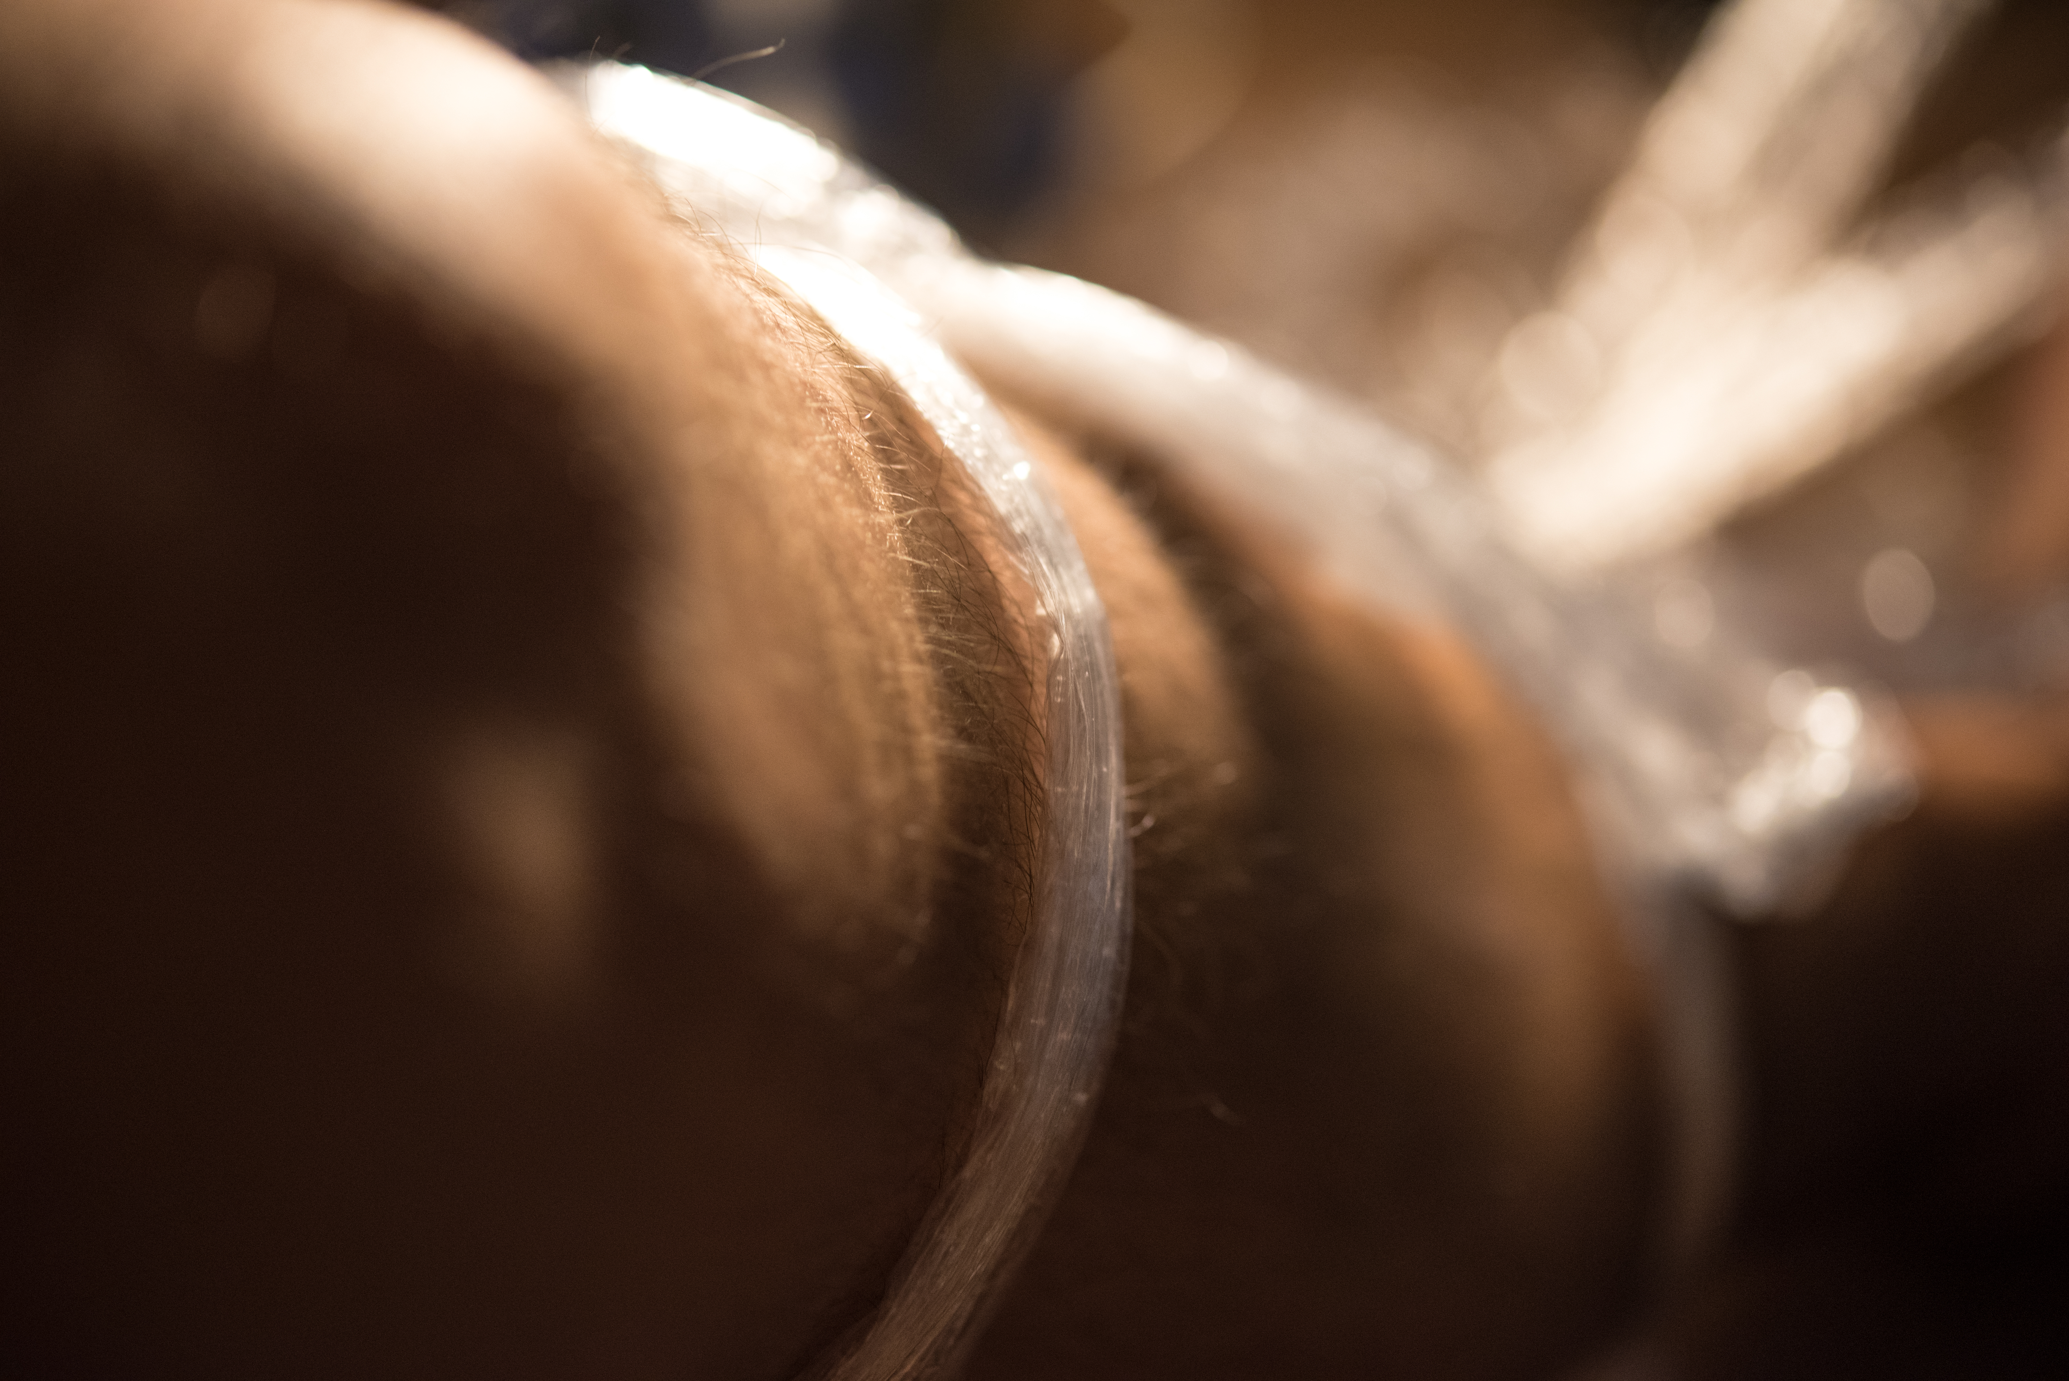

Paper & Ink

11”x 8.5”

Received: 3.4

Time Spent: 6 hours

Initial Reaction: 5/10

Cost of Materials: $16

This work was received not so well in crit and received an overall grade of 3.4 upon evaluation. The total hours/money spent on labor and cost of materials was below average.

Add To Cart: **$13.20** [See Pricing Sheet](Pricing%20Sheet.docx)